Assignment 1
Question:
Write a query for the HR department to produce the addresses of all the departments. Use the EMP and DEPT tables. Show the EMPNO, ENAME, SAL, DNAME and LOC in the output. Use a NATURAL JOIN.
Query:
SELECT EMPNO,
ENAME,
SAL,
DNAME,
LOC
FROM EMP_WIPRO;
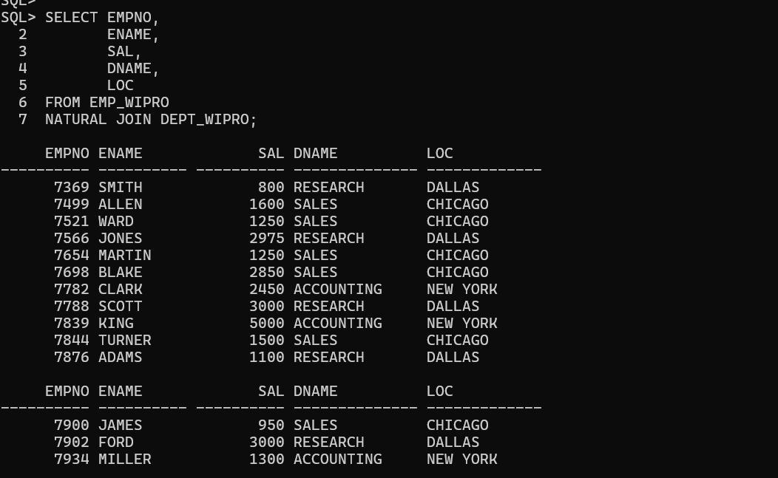
Assignment 2
Question:
The HR department needs a report of all employees. Write a query to display the JOB, MGR, SAL, COMM, DNAME of employees whose JOB is SALESMAN.
Query:
SELECT E.JOB,
E.MGR,
E.SAL,
E.COMM,
D.DNAME
FROM EMP_WIPRO E
JOIN DEPT_WIPRO D
ON E.DEPTNO = D.DEPTNO
WHERE E.JOB = 'SALESMAN';
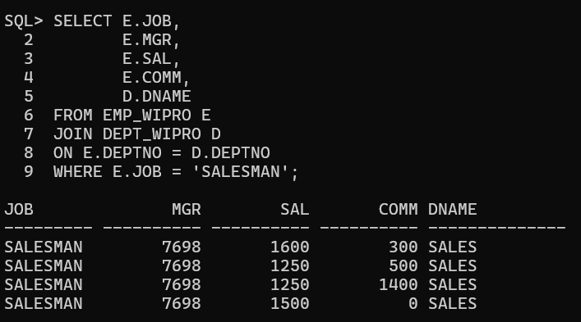
Assignment 3
Question:
The HR department needs a report of employees in LOC DALLAS. Display the ENAME, JOB, DEPTNO and DNAME for all employees who work in DALLAS.
Query:
SELECT E.ENAME,
E.JOB,
E.DEPTNO,
D.DNAME
FROM EMP_WIPRO E
JOIN DEPT_WIPRO D
ON E.DEPTNO = D.DEPTNO
WHERE D.LOC = 'DALLAS';
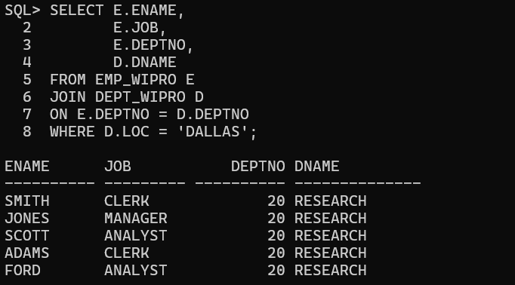
Assignment 4
Question:
Create a report to display employees' ename and employee number along with their manager's name and manager number. Label the columns Employee, Emp#, Manager, and Mgr#, respectively.
Query:
SELECT E.ENAME AS "Employee",
E.EMPNO AS "Emp#",
M.ENAME AS "Manager",
M.EMPNO AS "Mgr#"
FROM EMP_WIPRO E
JOIN EMP_WIPRO M
ON E.MGR = M.EMPNO;
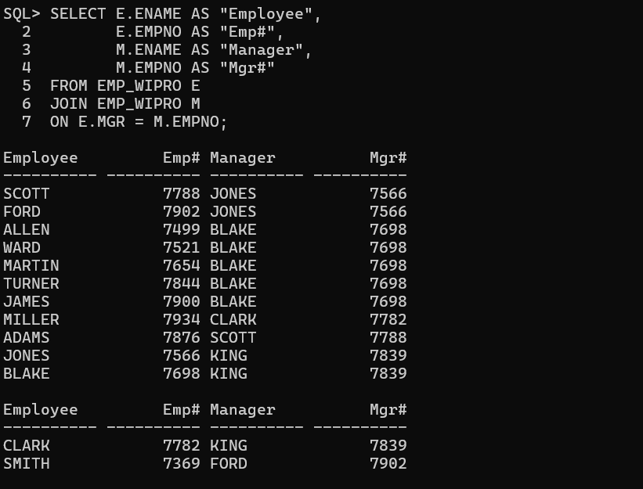
Assignment 5
Question:
Modify the previous query to display all employees including KING, who has no manager. Order the results by the employee number.
Query:
SELECT E.ENAME AS "Employee",
E.EMPNO AS "Emp#",
M.ENAME AS "Manager",
M.EMPNO AS "Mgr#"
FROM EMP_WIPRO E
LEFT OUTER JOIN EMP_WIPRO M
ON E.MGR = M.EMPNO
ORDER BY E.EMPNO;
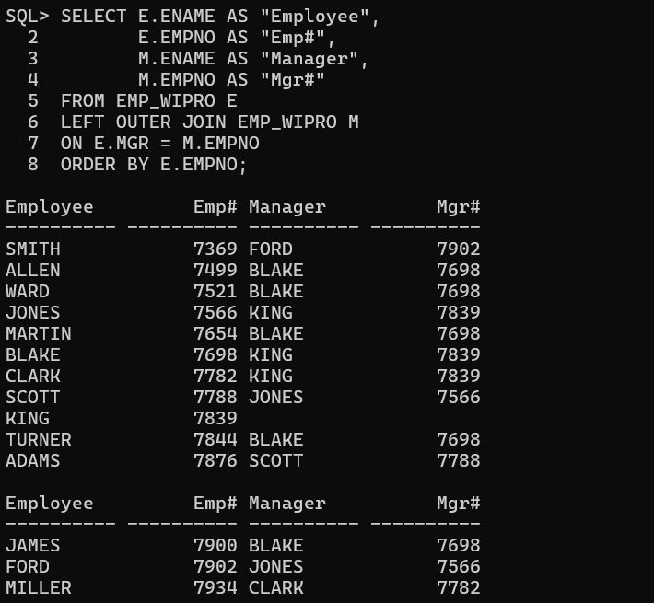
Assignment 6
Question:
The HR department needs a report on job grades and salaries. First show the structure of the SALGRADE table. Then display the name, job, department name, salary, and grade for all employees.
Query 1
DESC SALGRADE;
Query 2
SELECT E.ENAME,
E.JOB,
D.DNAME,
E.SAL,
S.GRADE
FROM EMP_WIPRO E
JOIN DEPT_WIPRO D
ON E.DEPTNO = D.DEPTNO
JOIN SALGRADE S
ON E.SAL BETWEEN S.LOSAL AND S.HISAL;
Output:
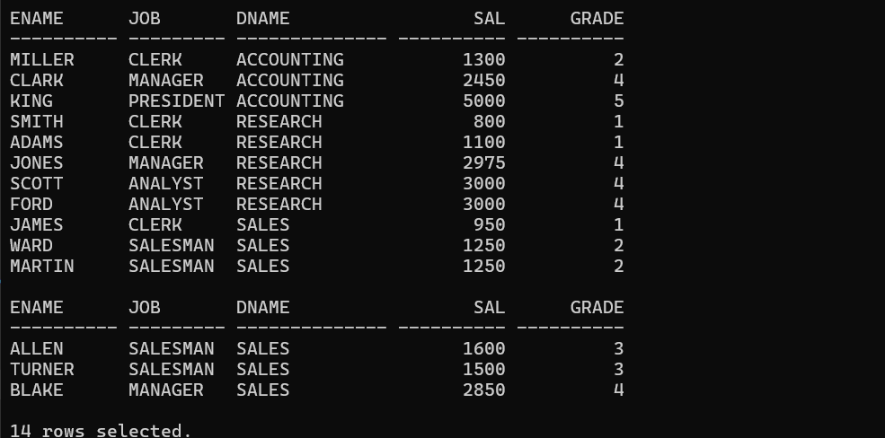
Assignment 7
Question:
Display the ENAME, DNAME of all the employees. Also display those department names which do not have any employees working.
Query:
SELECT E.ENAME,
D.DNAME
FROM EMP_WIPRO E
RIGHT OUTER JOIN DEPT_WIPRO D
ON E.DEPTNO = D.DEPTNO;
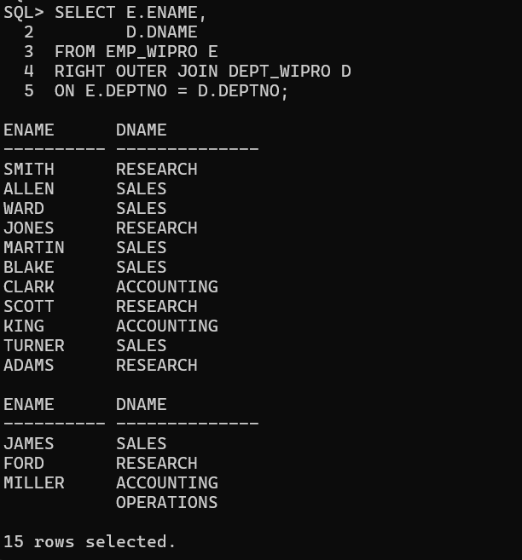
Assignment 8
Question:
The HR department needs to find the names and hire dates for all employees who were hired before their managers, along with their managers' names and hire dates.
Query:
SELECT E.ENAME,
E.HIREDATE,
M.ENAME AS MANAGER,
M.HIREDATE AS MANAGER_HIREDATE
FROM EMP_WIPRO E
LEFT OUTER JOIN EMP_WIPRO M
ON E.MGR = M.EMPNO
WHERE E.HIREDATE < M.HIREDATE;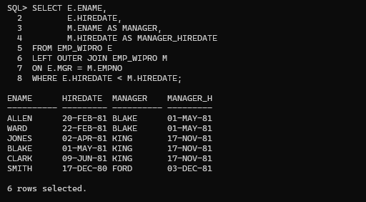
Assignment 9
Question:
Display the EMPNO, ENAME, DNAME, LOC of those employees who are working as CLERK. Use the USING clause.
Query:
SELECT EMPNO,
ENAME,
DNAME,
LOC
FROM EMP_WIPRO
JOIN DEPT_WIPRO
USING (DEPTNO)
WHERE JOB='CLERK'; 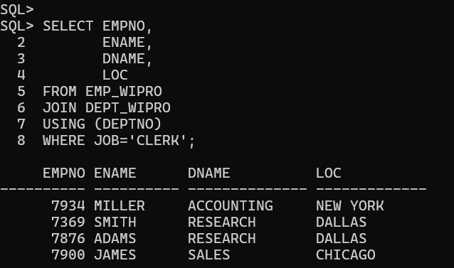
Assignment 10
Question:
Display the ENAME, SAL, MGR, DNAME of employees whose salary is more than 2000. Use the ON clause.
Query:
SELECT E.ENAME,
E.SAL,
E.MGR,
D.DNAME
FROM EMP_WIPRO E
JOIN DEPT_WIPRO D
ON E.DEPTNO = D.DEPTNO
WHERE E.SAL > 2000;
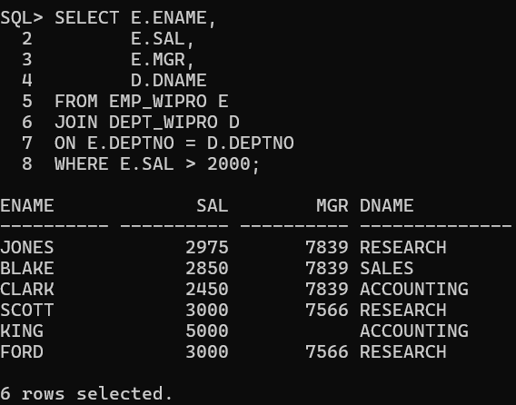
Assignment 11
Question:
Display the EMPNO, ENAME, JOB, DEPTNO, DNAME, LOC of employees. Use LEFT OUTER JOIN.
Query:
SELECT E.EMPNO,
E.ENAME,
E.JOB,
E.DEPTNO,
D.DNAME,
D.LOC
FROM EMP_WIPRO E
LEFT OUTER JOIN DEPT_WIPRO D
ON E.DEPTNO = D.DEPTNO;
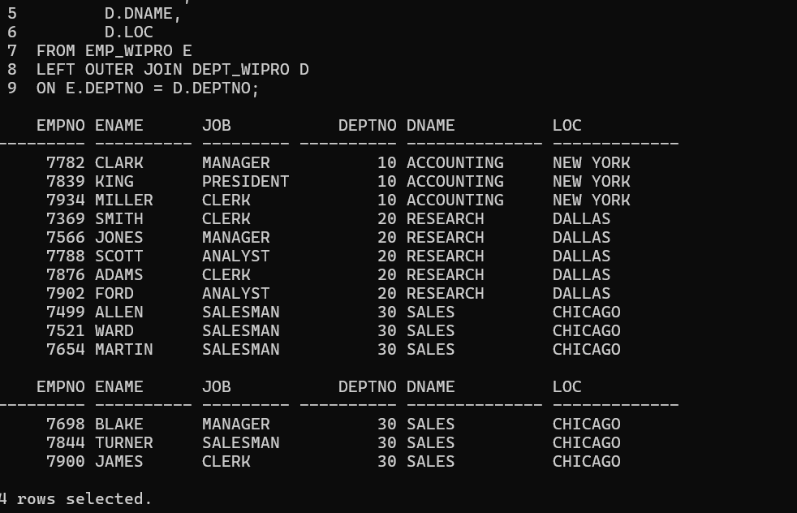

Assignment 12
Question:
Display the ENAME, DNAME of employees. Use RIGHT OUTER JOIN.
Query:
SELECT E.ENAME,
D.DNAME
FROM EMP_WIPRO E
RIGHT OUTER JOIN DEPT_WIPRO D
ON E.DEPTNO = D.DEPTNO;
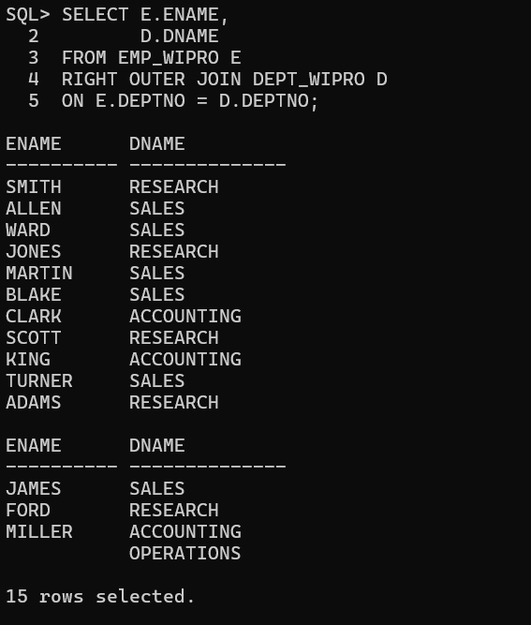
Assignment 13
Question:
Display the EMPNO, DNAME, LOC of employees. Use FULL OUTER JOIN.
Query:
SELECT E.EMPNO,
D.DNAME,
D.LOC
FROM EMP_WIPRO E
FULL OUTER JOIN DEPT_WIPRO D
ON E.DEPTNO = D.DEPTNO;
